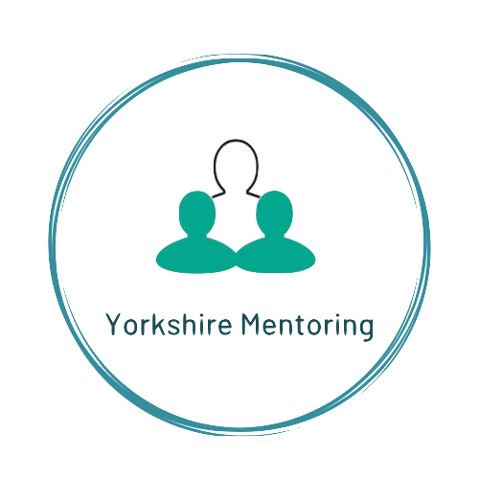
Mentoring for 11-18 year olds
Kirklees Referral Form

Please complete all pages and return via email to: kirklees@yorkshirementoring.org.uk

Remember to Password Protect before you send for Data Protection.

To password protect in word click Review in the tool bar above, click protect document icon.
& type the password & save
REFERRING ORGANISATION DETAILS

Referring Organisation
Name
Position
Telephone number
Email
In what capacity do you know the young person?
How long have/will you be working with the young person?
YOUNG PERSON DETAILS

Name
Address
Postcode
Any known learning needs?
Date of birth
Gender identified
Ethnicity Identified
Any known medical conditions or allergies
PARENT/CARER DETAILS

Name
Relationship to young person
Address
Postcode
Parent/Carer Phone Number/s

EDUCATION DETAILS

Name of school/college/AP/other
Year Group
Name of link staff member
Telephone
Email
Current education attendance rate as percentage for previous term/last 6 weeks
REFERRAL CRITERIA

Applicants must be 11 - 19 years old. They must consent to seeing a mentor. They must either live, be educated or work in Kirklees area.
We support young people who could be considered to be at risk. Research indicates those most ‘at risk’ meet multiple risk factors from those detailed below. Applicants must meet at least two risk factors.

Please put an ‘x’ against each risk factor relevant to the referral.

1 |  |  | Young people in or leaving care
2 |  |  | Young people excluded or at risk of exclusion from education
 |  |  | OR
 |  |  | Young people not in employment or training
3 |  |  | Young people displaying signs of anti–social, criminal behaviour, at risk of CCE or CSE exploitation
4 |  |  | Young people affected by drugs, crime and or alcohol directly or within their family
5 |  |  | Young people displaying emotional / behavioural problems linked to domestic
 |  |  | abuse, family issues, including a culture of offending within their family or missing from school or home

REASONS FOR REFERRAL

What are the reasons for the referral?

Please tick which areas you are looking to improve, please add any relevant additional information within the below FIVE areas.
In answering the question reference any risk factors you highlighted above, expanding each box as required.

Learning & Attainment

For example.
Improving positive values and beliefs, Increase aspirations and positive outcomes.

Improve Self-confidence and efficacy including positive relationships.

Parents/Carers & Home Life
What are the vulnerabilities
Wider Family, Peers & Environment
For example, is there a lack of Positive peer group; links to positive pastimes; and a need to develop new social interests

Other
If the young person has been cautioned or had interaction with the police or entered the Youth Justice System; ESP/ MST / YES

if known please detail here;

What do you hope might be achieved for this young person through mentoring?

Is there a specific target a that you are wanting to achieve?

Has the referred young person previously worked with Yorkshire Mentoring; this includes attending our Knife crime workshops Wrong Look Wrong Time Wrong Place?
Please delete Yes / No

If yes, please detail when and for how long:

YOUNG PERSON’S REASONS

Where possible, please support the young person referred to explain why they’d like to be mentored and what they would hope to gain:

I would like to be mentored because...

*YES / ESP

Have details of the young person been provided to Duty/ Early Support / Matrix information Yes/No If YES, please complete information below. If No, is there any reasons for this?
Date information sent.

If YES / ESP worker completing, detail date discussed / date received

Are there other professionals involved with the family or young person. YES/NO

Please detail all services known to be supporting young person (except school/AP/ college/employer already given).
Service | Contact | Phone | Email

DO YOU HAVE A CURRENT RISK ASSESMENT FOR THIS YOUNG PERSON? Yes/No
(Please attach)

I have agreed to share the above personal information, including any offending behaviour history, with Yorkshire Mentoring and understand that in giving this information, it will be treated in the strictest confidence & in terms with our SLA with Kirklees Council and Safer Kirklees.

I understand what working with Yorkshire Mentoring will involve.

Signature of Young Person: Date:

Signature of Parent / Carer: Date:

*Verbal agreement from young person, parent, carer is acceptable. If the referral is accepted, signed consent will be taken from to the parent / carer for community-based mentoring when met for introduction.
THANK YOU
We will contact the referrer on receiving the referral to confirm next steps

Please return completed forms to:
Kirklees@yorkshirementoring.org.uk
www.yorkshirementoring.org.uk
Remember to Password Protect before you send for Data Protection.

To password protect click Review in the tool bar, click protect document icon
& type the password & save

